006 Gulp - copy & src & dest

Gulp Kata List – Blog Page

[Gulp Kata List on GitHub](https://github.com/robertdunaway/katas-gulp)

# Duration

5 minutes

# Brief

In this kata we will copy our source files to a destination.

### For More Information

BING/GOOGLE: “Gulp src dest”

Book: <http://www.amazon.com/Gulp-Quick-guide-getting-running/dp/151468960X>

# Instructions

Get tutorial folder or the entire katas-angular2 repo.

Open the [before/*.sln] file and execute the kata.

Feel free to execute this kata multiple times because repetition creates motor memory.

# Github

* Before (start kata with this)
  + https://github.com/robertdunaway/katas-gulp/tree/master/006%20Gulp%20-%20copy%20%26%20src%20%26%20dest/before
* After
  + https://github.com/robertdunaway/katas-gulp/tree/master/006%20Gulp%20-%20copy%20%26%20src%20%26%20dest/after

# Kata

Create a task to copy all files from the “src” folder to the destination folder, “wwwroot”.

We copy our files to wwwroot because this is the default folder used by Asp.Net. Once the files are copied other tasks can operate against the files.

Keeping the source code and generated files apart make source control management cleaner and more obvious.

All that is required to copy files is gulp. No plugins need installed.

var gulp = require('gulp');

gulp.task('copy-to-wwwroot', function () {

return gulp.src(['src/**/*'])

.pipe(gulp.dest('wwwroot'));

});

The two commands, you’ll find in most files are:

gulp.src()

gulp.dest()

The result of executing the copy-to-wwwroot task is

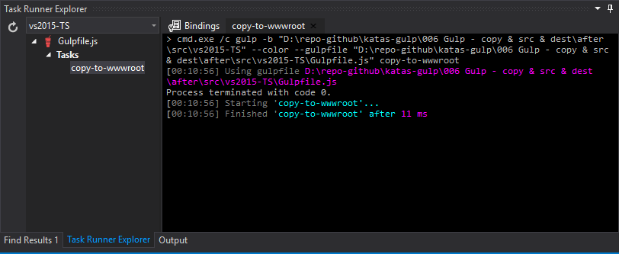

# Next

Take a few minutes and imagine more examples.